INSTITUTE OF PUBLIC ADMIN AND MANAGEMENT (IPAM)

Module: Software Engineering

**PROJECT PROPOSAL SOTFWARE ENGINEERING II FOR GROUP 4**

**NAME OF MEMBERS: ID NUMBER**

**MICHAEL KUTUBU 22022**

**SINNEH MICHAEL KARGBO 22473**

**MUSTAPHA BANGALIE SANKOH 22419**

**ABDULAZIZ CONTEH 22493**

**URL -** [**https://github.com/mustaphamichaelaziz/mustaphamichaelaziz.github.io**](https://github.com/mustaphamichaelaziz/mustaphamichaelaziz.github.io)

TITLE OF PROJECT:

**HOSPITAL MANAGEMENT SYSTEM (HMS)**

**REQUIREMENTS:**

Computer Software has revolutionized how we find, share, and store information. The digital world is moving at a rapid pace and doesn’t show any signs of slowing. For business, digitized operations have become a fundamental part of success. The title of the project is “Hospital Management system (HMS)”. This project will handle the whole activities of the hospital. HMS has most of the facilities that a modern hospital requires to computerize its day-to-day running. It will provide facilities to keep the records of Patients, Appointments, and Doctors with all their required details. It will contain facilities to generate various types of reports, Appointments, and Patient records which are required by the management during normal business operations to operate the hospital effectively. We have in this document, including the proposed designs of our systems, information on our ability to implement the scope of services described. The Hospital management system is a very laborious and lengthy procedure.

It requires a limited staff to perform these operations: appointment of Patients, recording of patient Information arrangement of Patient Records, and assign Patient to a Doctor. For an appointment to be given to a patient, the staff needs to go through a lot of paperwork in order not to duplicate Patient information and also to know which Doctor is assigned to that particular patient. All these matters make us thoughtful and instigate us to implement a system that will reduce the labor, cost, and time of the traditional Hospital Management system. For this reason, we have decided to make a system to design an automated Hospital Management System

**2. Feasibility Study:**

What are the user’s demonstrable needs?

User needs a solution which will have the all Appointment, Patient Records and Doctors Information, which will remove all the above-mentioned Problems that, the user is facing. The user wants a system which will reduce the bulk of paperwork, provide ease of work, flexibility, fast record finding, modifying, adding, removing and generating the reports.

# SYSTEM DESIGN

System Design is the solution to the creation of the new system. This is the important aspect made up of several steps. The complete, efficient and successful system should provide the following in succession: -

Where should we start………….?

Where should we go……………….?

Where should we end……………….?

If the project is to be successful, we will need answer to these questions. The answer of these questions is schema manner and is known as system design.

A systematic manner will be followed so as to achieve beneficial result at the end. It involves starting with a vague idea and ultimately developing it up into a useful system. The design phase is transition from a user oriented to a document oriented to the programmers.

Software report can be broken into a series of steps starting with the basic ideas and ending with the finished project.

**How can the problem be redefined?**

I proposed my perception of the system, in accordance with the problems of

existing system by making a full layout of the system on paper. I tallied the

problems and needs by existing system and requirements. I was further updating

in the layout in the basis of redefined the problems. In feasibility study phase

I had undergone through various steps, which are described as under:

How feasible is the system proposed? This was analyzed by comparing the following

factors with both the existing system and proposed system.

**Cost**

The cost required in the proposed system is comparatively less to the existing

system.

**Effort**

Compared to the existing system the proposed system will provide a better working

environment in which there will be ease of work and the effort required will be

comparatively less than the existing system.

**Time**

Also, the time required generating a report or for doing any other work will be

comparatively very less than in the existing system. Record finding and updating

will take less time than the existing system.

**Labor**

In the existing system the number of staff required for completing the work is

more while the new system will require quite a smaller number of staff.

# OBJECTIVES

This project is based on the Relational Database Management System (RDBMS) technology; the main objective of this project is to computerize the manual system & reduce the time consumption.

In other words, we can say that our project has the following objectives: -

* Make all the system Computerize
* Reduce time Consumption
* Reduce error scope
* All system management are automated
* Centralized database management
* easy operations for operator of the system
* No paper work requirement

**PROJECT CATEGORY**

This project as title “Hospital management system” is comes under the Relational Database Management System (RDBMS). This application will be developed with the help of MS Access and Visual Basic. This Combination come with high Flexible, Configurable and stable system that features many unique options and can be easily enhanced with custom options depending on the hospital’s feature and current needs by request.

**FUNCTIONAL FEATURE**

* We can always add new records by clicking on the **RECORD** button
* Underneath we also have another records box which display records for the Authorities to see or the Hospital management to see.
* The **RECTANGLE BOXES** are where we enter different appointment information, Doctors Information and Patient records.
* **The TOOLBAR YES** and **TOOLBAR NO** buttons are used to enable and disable the toolbar respectively.
* The **ADD RECORD** button is used to input new records, when click, it will open blank rectangle boxes for the user to input new records.
* The **PRINT RECORD** button allows the user to print records from the database, when click upon it will automatically takes
* The HMS is incorporated with a multi-user, multi-level authentication system which ensures that different users can only access the where their work is

**WHY HOSPITAL MANAGEMENT SYSTEM**

**Computations** of patients Appointments and other records is accurately done and is controlled by parameters that users can change.

**Online** Anytime a user can print off Patients records and Appointment. Any records made on the front end affects the final records leaving no room for batching.

**Multi-user and Multi-Locations** as long as server is powerful any number of users can work in the system concurrently

**SECURITY**

Set-up Time due to it simplicity HMS takes a short time for users to have theirs in the system

**Generating Reports –** HMS is designed in such a manner that it generates different kinds of reports for any duration

FUNCTIONALITIES/MODULE

# The steps for the successful project are as follows: -

* We should define problem completely and the goals should be known before our destination.
* In the next step, we should specify inputs and outputs of our interest.
* Then the structure of various database should design which will be used during the programming.
* In the next step, we should specify inputs and outputs of our interest and always provide a way to the user to read back the origin if he/she find any complex problem at any stage.
* We should know the function of each and every program which will leads us to or helps us to read at the specified goal.
* Then we write this individual program which later on joining solve our problem.
* Next steps involve then testing of program and corrections – if necessary.
* At last, linking all the programs in a well specified manner and combining in the form of a menu, submenu etc. Will be our defined.
* Out of these defined steps, few of the major steps will respect to Project

**“Hospital Management System”**

**DATA FLOW DIAGRAMS (DFD’S)**

We will use DFD diagram as a way of expressing the system in a graphical form. A DFD, also known as Bubble Chart, has a purpose of clarifying system requirement and identifying major transformation that will become the programs in the system design

1. A SQUARE defines a source or destination of system data
2. An **ARROW** identifies data flow or data in motion. It is a pipeline through which information flow.
3. **A CIRCLE** represents a process transforms in coming data flow into outgoing data flow.
4. An **OPEN RECTANGLE** is a data store or data at rest or a temporary rest repository of data.

Note that a **DFD** describe what data flow (logical) rather than they are processed, so it does not depend on hardware, software and data structure or file organization.

# PROCESSING OF HMS

**Patients**

**Doctor**

Appoint

A Hospital has to deal with three external entities: -

* The Doctor
* Appointments
* Patients

The above process shows that Doctor can directly communicate with the Patients and Patient can do the same also. Doctors can booked Appointments with Patient directly and Patient can as well do the same.

# DATABASE DESIGN

Database Design in most important in any project. We are using the following table to store the information related to staff of school

# 1. DOCTOR

Field Name NULL TYPE

DrID Not Null NUMBER (5)

EMPNAME VARCHAR (30)

ADRESS VARCHAR (30)

CITY VARCHAR (15)

PIN VARCHAR (6)

STATE VARCHAR (15)

PHONE VARCHAR (15)

MOBILE VARCHAR (13)

EMAIL VARCHAR (30)

SEX VARCHAR (1)

M_ STATUS VARCHAR (03)

DOB DATE

DOJ DATE

DEPT VARCHAR (30)

NATURE_OF_JOB VARCHAR (10)

BASIC_ PAY ARCHAR (10, 2)

|  |  |  |
| --- | --- | --- |
|  |  | |
| Field Name | NULL | Type |
| REGNO | NOT NULL | NUMBER (5) |
|  |  |  |
| NAME FNAME  MNAME |  | VARCHAR (25)  VARCHAR (25)  VARCHAR (25) |
| DOB  DOR |  | DATE  DATE |
| ADDRESS  CITY |  | VARCHAR (30)  VARCHAR (15) |
| STATE |  | VARCHAR (15) |
| PHONE |  | VARCHAR (15) |

|  |  |  |
| --- | --- | --- |
| 3. **APPOINTMENT** |  | |
| Field Name | NULL | Type |
| PATIENTID | NOT NULL | NUMBER (5) |
| DOCTORID  APPOINMENTID | NOTNULL  NOTNULL | NUMBER (5)  NUMBER (5) |
| APPOINTMENTDATE |  | NUMBER (5) |

# MODULES TO BE USE IN THE PROJECT

# This project shall include the following modules for development of the project. These are as follows: -

# SPLASH FORM

# This is a first form that displays the welcome screen for the user and also shows the information of developer or version etc.

# LOGIN FORM

This form shows the Login name and password when user enter a valid user name and password then he/she can operate the application.

# MAIN FORM

This form is a menu-based form that displays the menu for operation of the application. It includes various options for **Doctor**, **Patient**, **Appointments** and report related option.

# DOCTOR FORM

# This form provides the option to add, modify, delete or find the information of a Patient who seeks the solution in the hospital

# PATIENT FORM

This form provides the option to add, delete, search and delete the information of Patient.

# APPOINMENT FORM

This form provides the option to the user of the system to booked appointment, delete, modify and search the information.

**REPORT FORM**

With the help of this option from menu user of the system can see or take the print out of various reports provided by the system.

**NAME OF REPORTS**

Following are the reports names that are generated by the Project for the management of the hospital.

1. Details of Doctor Staff.
2. Details of Patient staff.
3. Date wise detail of Patient based on date of appointment.
4. Doctor’s report based on the Date of appointment.

# FUTURE SCOPE OF THE PROJECT.

# Nothing is perfect in this world. So, we are also no exception. Although, we will try our best to present the information effectively, yet, there can be further enhancement in the Application.

We will take care of all the critical aspects, which need to take care of during the development of the Project.

Like any other things, this project also has some limitations and can further be enhances by someone, because there are certain drawbacks that do not permit the system to be 100% accurate.

**HARDWARE & SOFTWARE REQUIREMENT**

Technologies used:

This project is a web application that is developed in Access having VISUAL BASIC as backend along with many other supporting technologies.

MICROSOFT ACCESS (OFFICE 365)

VISUAL BASIC

HTML

**Hardware Interface:**

Client Side:

PC:

A personal computer with the following configuration.

Processor: Pentium IV 2.0 and above.

RAM:

512 MB

Server Side:

PC:

A personal computer with the following configuration.

Processor:

Pentium IV 2.0 and above.

RAM:

1 GB

Disk space:

40GB

**Software Interface:**

Client Side:

Web Browser, Windows XP/Vista and above

Server Side:

Apache Server, Windows XP/Vista and above

Data Base Server:

MYSQL

**Communication Interface:**

The system should be accessed over LAN or WAN. For Clients to access application

server the network should be running TCP/IP protocol.

**System Interface:**

Application would be a self-contained system. It will not access data of any other

application nor will other application have access to its data.

**User Interface:**

Application will be accessed through a Microsoft Access Interface. The interface would be viewed best using 1024 x 768 and 800 x 600 pixels resolution setting.

Below is a display of the interface

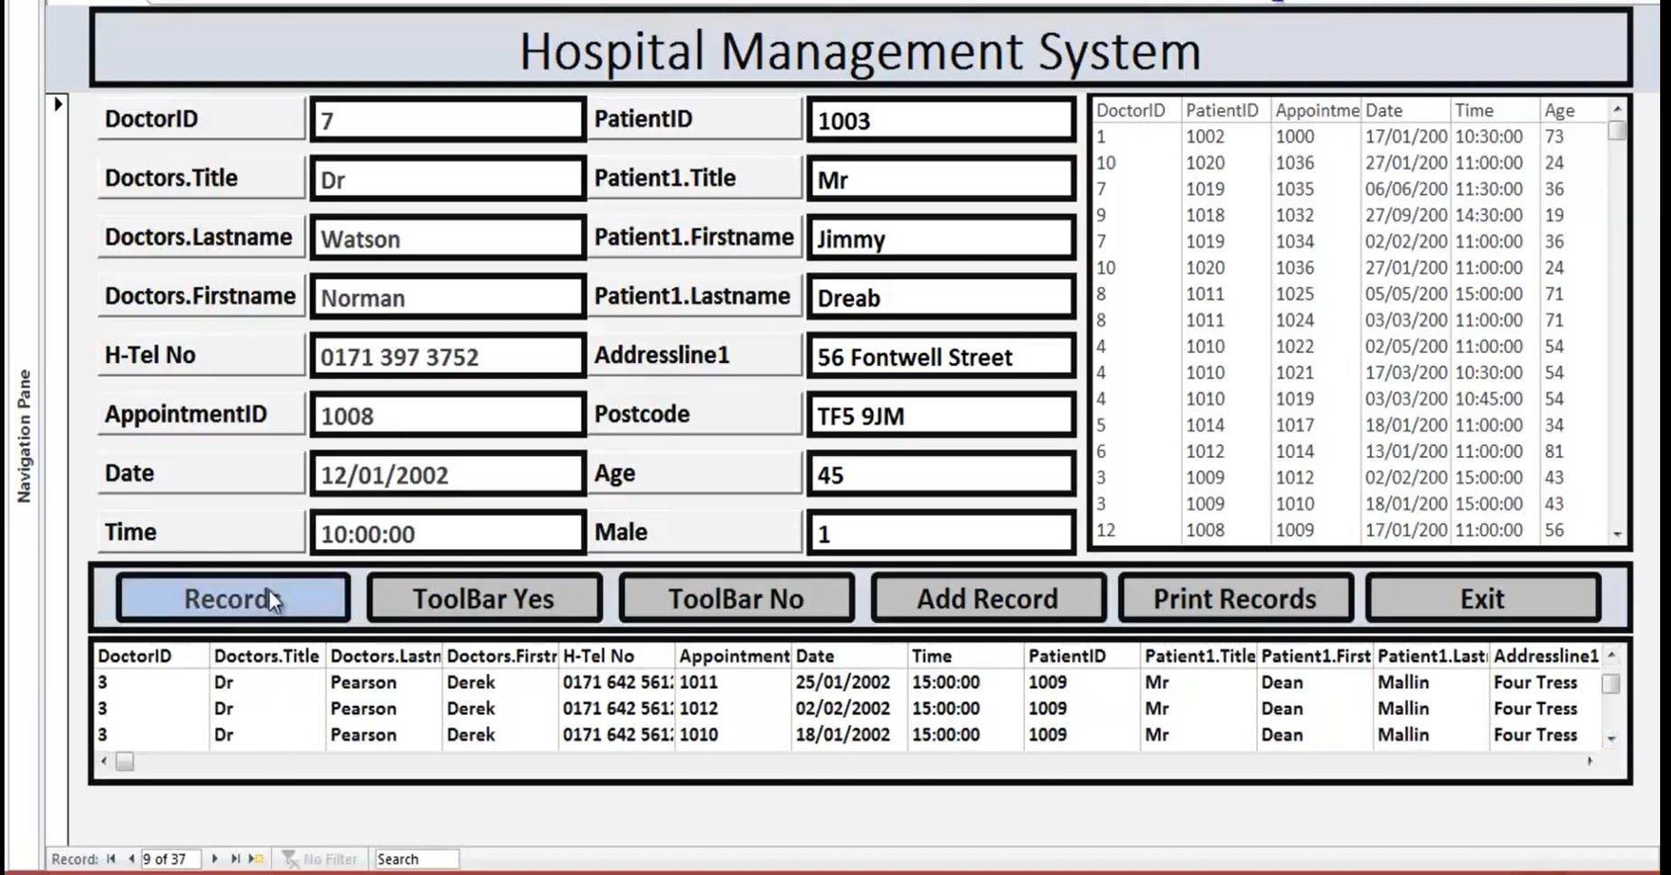

**Usability:**

The user is facilitated to view and make entries in the forms. Validations are provided in each field to avoid inconsistent or invalid entry in the databases. Reports screen contains text boxes so that reports can be produced.

**Security:**

Application will allow only valid office 365 users to access the system. Access to any

application resource will depend upon user’s designation. Security is based upon the individual user ID and Password.

**Maintainability:**

The installation and operation manual of hospital management system will be

provided to the user.

**Availability:**

System will be available around the clock except for the time required for the

backup of data.

**Portability:**

The application is developed in Microsoft Office 365. It would be portable to other operating system. As the database is made in Access, porting the database to another database server would require some development effort.

**Constraints:**

User interface is only in English i.e. no other language option is

available. Limited to Microsoft Access

**Acceptance Criteria:**

The software should meet the functional requirement and perform the functionality effectively and efficiently.

A user-friendly interface with proper menus.

Data transfer should be accurate and within a reasonable amount of time keeping in mind the network traffic.

The system should not allow entry of duplicate key values.

System should have the ability to generate transactional Logs to avoid any accidental loss of data.

**Proposed Milestones:**

Although it’s not possible to calculate the exact time for the development of the

project, I have made an approximate timeline for the development of my project and

it is as follows:

|  |  |  |  |
| --- | --- | --- | --- |
| Stages of Development | Starting Date | Ending Date | Duration in days |
| Initial Study | 11/09/2020 | 18/09/2020 | 4 days |
| Feasibility Study | 21/09/2020 | 30/09/2020 | 9 days |
| Requirement Analysis | 4/10/2020 | 14/10/2020 | 10 days |
| Requirement Specification | 16/10/2020 | 21/10/2020 | 5 days |
| Interface Design | 23/10/2020 | 5/11/2020 | 13 days |
| Coding | 6/11/2020 | 10/11/2020 | 4 days |
| Testing and Debugging | 11/11/2020 | 13/11/2020 | 2 days |
| Implementation | 14/11/2020 | 16/11/2020 | 2 days |
|  |  | Total | 49 Days |

16. Proposed Cost:

1. Development Cost: Not Applicable

2. Maintenance Cost: Not Applicable

17. Acknowledgement:

We are hereby acknowledged that we will abide by the rules and regulations prescribed in the project manual and submit the project within the proposed time.